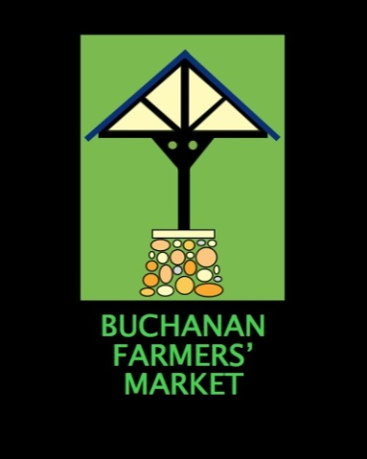
VENDOR APPLICATION

574-213-4774
The market will be a drop-off point for food donations for Red Bud Area Ministries (RAM) and Little Pantries again this year.

PRINT CLEARLY
Name ________________________________________________________________________
Mailing Address ________________________________________________________________
________________________________________________________________
Contact Phone Number __________________________________________________________
Email Address __________________________________________________________________
Business’ Name _________________________________________________________________
Products to sell _________________________________________________________________
Preference: _____ Permanent Booth _____ Own Setup
Payment: Tent space dates chosen: $5 x ______ = _______
___Permanent Booth $180 full season
___Tent Space $120 full season
DATES FOR 2024
May 4 June 1 July 6
11 8 13
18 15 20
25 22 27
29

August 3 September 7 October 5
10 14 12
17 21
24 28
31
After April 27, call the market phone (number above) and get on our list to vendor. Bring your forms with you the first day you vend.

